**HTML FILES:**

**ACCOUNT PAGE**

<!DOCTYPE html>

<html lang = "en">

<head>

<meta charset="UTF-8">

<meta name ="viewport" content = "width = device-width, initial-scale =1.0">

<title>All Products - RedStore</title>

<link rel="stylesheet" href="style.css" >

<link rel="preconnect" href="https://fonts.googleapis.com">

<link rel="preconnect" href="https://fonts.gstatic.com" crossorigin>

<link href="https://fonts.googleapis.com/css2?family=Poppins:wght@300;400;500;600;700&display=swap"

rel="stylesheet">

<link rel="stylesheet" href="https://stackpath.bootstrapcdn.com/font-awesome/4.7.0/css/font-awesome.min.css">

</head>

<body>

<div class="container">

<div class="navbar">

<div class="logo">

<img src="images/logo.png" width="125px">

</div>

<nav>

<ul id = "MenuItems">

<li><a href=""> Home </a> </li>

<li><a href=""> Products </a> </li>

<li><a href=""> About </a> </li>

<li><a href=""> Contact </a> </li>

<li><a href=""> Account </a> </li>

</ul>

</nav>

<img src="images/cart.png" width="30px" height="30px">

<img src="images/menu.png" class="menu-icon"

onclick ="menutoggle()">

</div>

</div>

<!---------------------- account-page --------------------->

<div class="account-page">

<div class="container">

<div class="row">

<div class="col-2">

<img src="images/image1.png" width="100%">

</div>

<div class="col-2">

<div class="form-container">

<div class="form-btn">

<span onclick="login()">Login</span>

<span onclick="register()">Register</span>

<hr id="Indicator">

</div>

<div id = "login-error-msg-holder">

<p id ="login-error-msg"> Invalid username <span id="error-msg-second-line"> and / or password</span></p>

</div>

<form id="LoginForm" action="index.html">

<input type="text" name="username" id ="username-field" class="login-form-field" required placeholder="Username">

<input type="password" name="password" id ="password-field" class="login-form-field" required placeholder="Password">

<button type= "submit" value ="Login" id="login-form-sumbit" class="btn">Login <a href="index.html"> </a> </button>

<a href="">Forget Password</a>

</form>

<form id="RegForm" action="index.html">

<input type="text" name="username" id ="username-field" class="login-form-field" required placeholder="Username">

<input type="email" name="email" id ="email-field" class="login-form-field" required placeholder="Email">

<input type="password" name="password" id ="password-field" class="login-form-field" required placeholder="Password">

<button type= "submit" value ="Register" id="register-form-sumbit" class="btn">Register </button>

</form>

</div>

</div>

</div>

</div>

</div>

<!--------------------- footer -------------------->

<div class="footer">

<div class="container">

<div class="row">

<div class="footer-col-3">

<h3>Download Our App</h3>

<p>Download App for Android and ios mobile phone.</p>

<div class="app-logo">

<img src="images/play-store.png">

<img src="images/app-store.png">

</div>

</div>

<div class="footer-col-3">

<img src="images/logo-white.png">

<p>Our Purpose Is To Sustainably Make the Pleasure and

Benefits of Sports Accessible to the Many.</p>

</div>

<div class="footer-col-3">

<h3>Useful Links</h3>

<ul>

<li>Coupons</li>

<li>Blog Post</li>

<li>Return Policy</li>

<li>Join Affilicate</li>

</ul>

</div>

<div class="footer-col-3">

<h3>Contact & Follow us</h3>

<ul>

<li><a href="https://Facebook.com">Facebook </a></li>

<li><a href="https://Linkedin.com">LinkedIn </a></li>

<li><a href="https://Telegram.com">Telegram </a></li>

<li><a href="https://Instagram.com">Instagram </a></li>

<li><a href="https://YouTube.com">You Tube </a></li>

<li>91-9080734675</li>

</ul>

</div>

</div>

<hr>

<p class="Copyright">Copyright 2022 - Salman Basha - JAMAL MOHAMED COLLEGE</p>

</div>

</div>

<!--------------------- js for toggle menu -------------------->

<script>

var MenuItems = document.getElementById("MenuItems");

MenuItems.style.maxHeight = "0px";

function menutoggle()

{

if(MenuItems.style.maxHeight == "0px")

{

MenuItems.style.maxHeight = "200px";

}

else

{

MenuItems.style.maxHeight = "0px";

}

}

</script>

<!--------------------- js for form -------------------->

<script>

var LoginForm = document.getElementById("LoginForm");

var RegForm = document.getElementById("RegForm");

var Indicator = document.getElementById("Indicator");

function login(){

RegForm.style.transform = "translateX(300px)";

LoginForm.style.transform = "translateX(300px)";

Indicator.style.transform = "translateX(0px)";

}

function register(){

RegForm.style.transform = "translateX(0px)";

LoginForm.style.transform = "translateX(0px)";

Indicator.style.transform = "translateX(100px)";

}

</script>

</body>

</html>

**HOME PAGE**

<!DOCTYPE html>

<html lang = "en">

<head>

<meta charset="UTF-8">

<meta name ="viewport" content = "width = device-width, initial-scale =1.0">

<title>RedStore | Ecommerce Website Design </title>

<link rel="stylesheet" href="style.css" >

<link rel="preconnect" href="https://fonts.googleapis.com">

<link rel="preconnect" href="https://fonts.gstatic.com" crossorigin>

<link href="https://fonts.googleapis.com/css2?family=Poppins:wght@300;400;500;600;700&display=swap"

rel="stylesheet">

<link rel="stylesheet" href="https://stackpath.bootstrapcdn.com/font-awesome/4.7.0/css/font-awesome.min.css">

</head>

<body>

<div class="header">

<div class="container">

<div class="navbar">

<div class="logo">

<a href="index.html"><img src="images/logo.png" width="125px"> </a>

</div>

<nav>

<ul id = "MenuItems">

<li><a href="index.html"> Home </a> </li>

<li><a href="products.html"> Products </a> </li>

<li><a href="about.html"> About </a> </li>

<li><a href="contact.html"> Contact </a> </li>

<li><a href="account.html"> Account </a> </li>

</ul>

</nav>

<a href="cart.html"><img src="images/cart.png" width="30px" height="30px"></a>

<img src="images/menu.png" class="menu-icon"

onclick ="menutoggle()">

</div>

<div class="row">

<div class="col-6">

<h1>Give Your Workout<br>A New Style!</h1>

<p>Sucess isn't always about greatness. It's about consistency.

Consistent<br>hard work gains success. Greatness

will come.</p>

<a href="" class="btn">Explore Now &#8594;</a>

</div>

<div class="col-6">

<img src="images/image1.png" >

</div>

</div>

</div>

</div>

<!---------------------- featured categories --------------------->

<div class="categories">

<div class="small-container">

<div class="row">

<div class="col-4">

<img src="images/category-1.jpg">

</div>

<div class="col-4">

<img src="images/category-2.jpg">

</div>

<div class="col-4">

<img src="images/category-3.jpg">

</div>

</div>

</div>

</div>

<!---------------------- featured products --------------------->

<div class="small-container">

<h2 class="title">Featured Products</h2>

<div class="row">

<div class="col-3">

<a href="product-details.html"><img src="images/product-1.jpg"> </a>

<a href="product-details.html"><h4>Red Printed T-Shirt</h4></a>

<div class="rating">

<i class="fa fa-star"></i>

<i class="fa fa-star"></i>

<i class="fa fa-star"></i>

<i class="fa fa-star"></i>

<i class="fa fa-star-o"></i>

</div>

<p>$45.00</p>

</div>

<div class="col-3">

<img src="images/product-2.jpg">

<h4>Black Casual Shoes</h4>

<div class="rating">

<i class="fa fa-star"></i>

<i class="fa fa-star"></i>

<i class="fa fa-star"></i>

<i class="fa fa-star-half-o"></i>

<i class="fa fa-star-o"></i>

</div>

<p>$30.00</p>

</div>

<div class="col-3">

<img src="images/product-3.jpg">

<h4>Grey Track Pant</h4>

<div class="rating">

<i class="fa fa-star"></i>

<i class="fa fa-star"></i>

<i class="fa fa-star"></i>

<i class="fa fa-star"></i>

<i class="fa fa-star-half-o"></i>

</div>

<p>$35.00</p>

</div>

<div class="col-3">

<img src="images/product-4.jpg">

<h4>Puma Blue T-Shirt</h4>

<div class="rating">

<i class="fa fa-star"></i>

<i class="fa fa-star"></i>

<i class="fa fa-star"></i>

<i class="fa fa-star"></i>

<i class="fa fa-star-o"></i>

</div>

<p>$50.00</p>

</div>

</div>

<h2 class="title">Latest Products</h2>

<div class="row">

<div class="col-3">

<img src="images/product-5.jpg">

<h4>Gray Casual Shoes</h4>

<div class="rating">

<i class="fa fa-star"></i>

<i class="fa fa-star"></i>

<i class="fa fa-star"></i>

<i class="fa fa-star"></i>

<i class="fa fa-star-o"></i>

</div>

<p>$35.00</p>

</div>

<div class="col-3">

<img src="images/product-6.jpg">

<h4>Puma Black T-Shirt</h4>

<div class="rating">

<i class="fa fa-star"></i>

<i class="fa fa-star"></i>

<i class="fa fa-star"></i>

<i class="fa fa-star-half-o"></i>

<i class="fa fa-star-o"></i>

</div>

<p>$50.00</p>

</div>

<div class="col-3">

<img src="images/product-7.jpg">

<h4>Three Combo Socks </h4>

<div class="rating">

<i class="fa fa-star"></i>

<i class="fa fa-star"></i>

<i class="fa fa-star"></i>

<i class="fa fa-star"></i>

<i class="fa fa-star-half-o"></i>

</div>

<p>$25.00</p>

</div>

<div class="col-3">

<img src="images/product-8.jpg">

<h4>Black Wrist Watch</h4>

<div class="rating">

<i class="fa fa-star"></i>

<i class="fa fa-star"></i>

<i class="fa fa-star"></i>

<i class="fa fa-star"></i>

<i class="fa fa-star-o"></i>

</div>

<p>$50.00</p>

</div>

</div>

<div class="row">

<div class="col-3">

<img src="images/product-9.jpg">

<h4>Black Wrist Watch</h4>

<div class="rating">

<i class="fa fa-star"></i>

<i class="fa fa-star"></i>

<i class="fa fa-star"></i>

<i class="fa fa-star"></i>

<i class="fa fa-star-o"></i>

</div>

<p>$45.00</p>

</div>

<div class="col-3">

<img src="images/product-10.jpg">

<h4>Black Casual Shoes</h4>

<div class="rating">

<i class="fa fa-star"></i>

<i class="fa fa-star"></i>

<i class="fa fa-star"></i>

<i class="fa fa-star-half-o"></i>

<i class="fa fa-star-o"></i>

</div>

<p>$38.00</p>

</div>

<div class="col-3">

<img src="images/product-11.jpg">

<h4>Gray Casual Shoes</h4>

<div class="rating">

<i class="fa fa-star"></i>

<i class="fa fa-star"></i>

<i class="fa fa-star"></i>

<i class="fa fa-star"></i>

<i class="fa fa-star-half-o"></i>

</div>

<p>$35.00</p>

</div>

<div class="col-3">

<img src="images/product-12.jpg">

<h4>Black Track Pant</h4>

<div class="rating">

<i class="fa fa-star"></i>

<i class="fa fa-star"></i>

<i class="fa fa-star"></i>

<i class="fa fa-star"></i>

<i class="fa fa-star-o"></i>

</div>

<p>$50.00</p>

</div>

</div>

</div>

<!--------------------- Offer -------------------->

<div class="offer">

<div class="small-container">

<div class="row">

<div class="col-6">

<img src="images/exclusive.png" class="offer-img">

</div>

<div class="col-6">

<p>Exclusively Available on RedStore</p>

<h1>Smart Band 4</h1>

<small>The Mi Smart Band 4 features a 39.9% larger

(than Mi Band 3)AMOLED color full-touch display with

adjustable brightness,So everything is clear as can be.</small>

<a href="" class="btn">Buy Now &#8594;</a>

</div>

</div>

</div>

</div>

<!------About Section------->

<div class="about">

<div class="container">

<h1 class="title"> About Us </h1>

<div class="row">

<div class="col-6">

<div class="about-content">

Welcome to Red Store, your number one source for all things. We're dedicated to giving you the very best of services, with a focus on dependability, customer service and uniqueness.

Founded in 2022 by Salman Basha, Sports Compass has come a long way from its beginnings in a Copenhagen. When Daniel Brown first started out, his passion for helping other parents be more eco-friendly, providing the best equipment for his fellow sports lover drove him to do intense research, quit his day job, and gave him the impetus to turn hard work and inspiration into to a booming online store. We now serve customers all over the US, the world, the Austin area, and are thrilled to be a part of the quirky, eco-friendly, fair trade wing of the sports industry.

We hope you enjoy our products as much as we enjoy offering them to you. If you have any questions or comments, please don't hesitate to contact us.

</div>

<button type="button" class="btn btn-primary">Read More>>

</button>

</div>

<div class="col-6 skills-bar">

<h3>Delivery Rate</h3>

<div class="progress">

<progress id="file" max="100" value="85"> 85% </progress>

<div class="progress-bar" style = "width:85%";>85%</div>

</div>

<h3>Customer Growth</h3>

<div class="progress">

<progress id="file" max="100" value="75"> 75% </progress>

<div class="progress-bar" style = "width:75%";>75%</div>

</div>

<h3>Happy Employee</h3>

<div class="progress">

<progress id="file" max="100" value="95"> 95% </progress>

<div class="progress-bar" style = "width:95%";>95%</div>

</div>

</div>

</div>

</div>

</div>

<!------Services Section------->

<div class="services">

<div class="small-container">

<h1 class="title">Our Services</h1>

<div class="row services" >

<div class= "col-4 text-center">

<div class="icon">

<i class="fa fa-phone"></i>

</div>

<h3> 24/7 Support</h3>

<p>on order related queries</p>

</div>

<div class="col-4 text-center">

<div class="icon">

<i class="fa fa-shopping-cart"></i>

</div>

<h3> Return within 30 days</h3>

<p>of receiving your order</p>

</div>

<div class="col-4 text-center">

<div class="icon">

<i class="fa fa-truck"></i>

</div>

<h3>Get free delivery</h3>

<p>on orders above 99 dollar</p>

</div>

</div>

</div>

</div>

</div>

<!--------------------- testimonial -------------------->

<div class="testimonial">

<div class="small-container">

<div class="row">

<div class="col-4">

<i class="fa fa-quote-left"></i>

<p>This is simply dummy text of the printing

and typesetting industry. Lorem Ipsum has been the

industry's standard dummy text ever</p>

<div class="rating">

<i class="fa fa-star"></i>

<i class="fa fa-star"></i>

<i class="fa fa-star"></i>

<i class="fa fa-star"></i>

<i class="fa fa-star-o"></i>

</div>

<img src="images/user-4.jpg">

<h3>Salman Basha</h3>

</div>

<div class="col-4">

<i class="fa fa-quote-left"></i>

<p>This is simply dummy text of the printing

and typesetting industry. Lorem Ipsum has been the

industry's standard dummy text ever</p>

<div class="rating">

<i class="fa fa-star"></i>

<i class="fa fa-star"></i>

<i class="fa fa-star"></i>

<i class="fa fa-star"></i>

<i class="fa fa-star-o"></i>

</div>

<img src="images/user-5.png">

<h3>Justin Parker</h3>

</div>

<div class="col-4">

<i class="fa fa-quote-left"></i>

<p>This is simply dummy text of the printing

and typesetting industry. Lorem Ipsum has been the

industry's standard dummy text ever</p>

<div class="rating">

<i class="fa fa-star"></i>

<i class="fa fa-star"></i>

<i class="fa fa-star"></i>

<i class="fa fa-star"></i>

<i class="fa fa-star-o"></i>

</div>

<img src="images/user-6.jpg">

<h3>Cillian Murphy</h3>

</div>

</div>

</div>

</div>

<!--------------------- brands -------------------->

<div class="brands">

<div class="small-container">

<div class="row">

<div class="col-2">

<img src="images/logo-godrej.png">

</div>

<div class="col-2">

<img src="images/logo-oppo.png">

</div>

<div class="col-2">

<img src="images/logo-coca-cola.png">

</div>

<div class="col-2">

<img src="images/logo-paypal.png">

</div>

<div class="col-2">

<img src="images/logo-philips.png">

</div>

<div class="col-2">

<img src="images/logo-Starbucks.jpg">

</div>

</div>

</div>

</div>

<!--------------------- contact -------------------->

<div class="contact">

<div class="small-container">

<H1 class="title">Get In Touch</H1>

<div class="row">

<div class="col-6">

<form class="contact-form">

<div class ="form-group">

<input type="text" class="form-control" placeholder="Your Name..">

</div>

<div class ="form-group">

<input type="number" class="form-control" placeholder="Phone No..">

</div>

<div class ="form-group">

<input type="email" class="form-control" placeholder="Email..">

</div>

<div class ="form-group">

<textarea class="form-control" row="4" placeholder="Message.."></textarea>

</div>

<button type = "submit" class="btn btn-primary">Submit </button>

</form>

</div>

<div class="col-6 contact-info">

<div class="follow"> <b> <i class="fa fa-map-maker"></i> </b> Kovilpatti road, Manaparai, Trichy </div>

<div class="follow"> <b> <i class="fa fa-mobile"></i> </b> (+91) 9080734675 </div>

<div class="follow"> <b> <i class="fa fa-envelope"></i> </b> redstore@gmail.com </div>

<div class="follow"> <label> <b>Get Social </b> </label>

<a href = "https://www.Facebook.com/"><i class ="fa fa-facebook"> </i> </a>

<a href = "https://www.youtube.com/"><i class ="fa fa-youtube-play"> </i> </a>

<a href = "https://www.twitter.com/"><i class ="fa fa-twitter"> </i> </a>

<a href = "https://www.instagram.com/"><i class ="fa fa-instagram"> </i> </a>

<a href = "https://www.myaccount.google.com/"><i class ="fa fa-google-plus"> </i> </a>

</div>

</div>

</div>

</div>

</div>

<!--------------------- footer -------------------->

<div class="footer">

<div class="container">

<div class="row">

<div class="footer-col-13">

<h3>Download Our App</h3>

<p>Download App for Android and ios mobile phone.</p>

<div class="app-logo">

<img src="images/play-store.png">

<img src="images/app-store.png">

</div>

</div>

<div class="footer-col-3">

<img src="images/logo-white.png">

<p>Our Purpose Is To Sustainably Make the Pleasure and

Benefits of Sports Accessible to the Many.</p>

</div>

<div class="footer-col-3">

<h3>Useful Links</h3>

<ul>

<li>Coupons</li>

<li>Blog Post</li>

<li>Return Policy</li>

<li>Join Affilicate</li>

</ul>

</div>

<div class="footer-col-3">

<h3>Contact & Follow us</h3>

<ul>

<li><a href="https://Facebook.com">Facebook </a></li>

<li><a href="https://Linkedin.com">LinkedIn </a></li>

<li><a href="https://Telegram.com">Telegram </a></li>

<li><a href="https://Instagram.com">Instagram </a></li>

<li><a href="https://YouTube.com">You Tube </a></li>

<li>91-9080734675</li>

</ul>

</div>

</div>

<hr>

<p class="Copyright">Copyright 2022 - Salman Basha - JAMAL MOHAMED COLLEGE</p>

</div>

</div>

<!--------------------- js for toggle menu -------------------->

<script>

var MenuItems = document.getElementById("MenuItems");

MenuItems.style.maxHeight = "0px";

function menutoggle()

{

if(MenuItems.style.maxHeight == "0px")

{

MenuItems.style.maxHeight = "200px";

}

else

{

MenuItems.style.maxHeight = "0px";

}

}

</script>

</body>

</html>

**PRODUCT PAGE**

<!DOCTYPE html>

<html lang = "en">

<head>

<meta charset="UTF-8">

<meta name ="viewport" content = "width = device-width, initial-scale =1.0">

<title>All Products - RedStore</title>

<link rel="stylesheet" href="style.css" >

<link rel="preconnect" href="https://fonts.googleapis.com">

<link rel="preconnect" href="https://fonts.gstatic.com" crossorigin>

<link href="https://fonts.googleapis.com/css2?family=Poppins:wght@300;400;500;600;700&display=swap"

rel="stylesheet">

<link rel="stylesheet" href="https://stackpath.bootstrapcdn.com/font-awesome/4.7.0/css/font-awesome.min.css">

</head>

<body>

<div class="container">

<div class="navbar">

<div class="logo">

<a href="index.html"><img src="images/logo.png" width="125px"></a>

</div>

<nav>

<ul id = "MenuItems">

<li><a href="index.html"> Home </a> </li>

<li><a href="products.html"> Products </a> </li>

<li><a href="about.html"> About </a> </li>

<li><a href="contact.html"> Contact </a> </li>

<li><a href="account.html"> Account </a> </li>

</ul>

</nav>

<a href="cart.html"><img src="images/cart.png" width="30px" height="30px"></a>

<img src="images/menu.png" class="menu-icon"

onclick ="menutoggle()">

</div>

</div>

<!---------------------- products --------------------->

<div class="small-container">

<div class="row row-2">

<h2>All Products</h2>

<select>

<option>Default Shorting</option>

<option>Short by Price</option>

<option>Short by Popularity</option>

<option>Short by rating</option>

<option>Short by Sale</option>

</select>

</div>

<div class="row">

<div class="col-3">

<a href="product-details.html"><img src="images/product-1.jpg"></a>

<a href="product-details.html"><h4>Red Printed T-Shirt</h4></a>

<div class="rating">

<i class="fa fa-star"></i>

<i class="fa fa-star"></i>

<i class="fa fa-star"></i>

<i class="fa fa-star"></i>

<i class="fa fa-star-o"></i>

</div>

<p>$45.00</p>

</div>

<div class="col-3">

<img src="images/product-2.jpg">

<h4>Black Casual Shoes</h4>

<div class="rating">

<i class="fa fa-star"></i>

<i class="fa fa-star"></i>

<i class="fa fa-star"></i>

<i class="fa fa-star-half-o"></i>

<i class="fa fa-star-o"></i>

</div>

<p>$30.00</p>

</div>

<div class="col-3">

<img src="images/product-3.jpg">

<h4>Grey Track Pant</h4>

<div class="rating">

<i class="fa fa-star"></i>

<i class="fa fa-star"></i>

<i class="fa fa-star"></i>

<i class="fa fa-star"></i>

<i class="fa fa-star-half-o"></i>

</div>

<p>$35.00</p>

</div>

<div class="col-3">

<img src="images/product-4.jpg">

<h4>Puma Blue T-Shirt</h4>

<div class="rating">

<i class="fa fa-star"></i>

<i class="fa fa-star"></i>

<i class="fa fa-star"></i>

<i class="fa fa-star"></i>

<i class="fa fa-star-o"></i>

</div>

<p>$50.00</p>

</div>

</div>

<div class="row">

<div class="col-3">

<img src="images/product-5.jpg">

<h4>Gray Casual Shoes</h4>

<div class="rating">

<i class="fa fa-star"></i>

<i class="fa fa-star"></i>

<i class="fa fa-star"></i>

<i class="fa fa-star"></i>

<i class="fa fa-star-o"></i>

</div>

<p>$35.00</p>

</div>

<div class="col-3">

<img src="images/product-6.jpg">

<h4>Puma Black T-Shirt</h4>

<div class="rating">

<i class="fa fa-star"></i>

<i class="fa fa-star"></i>

<i class="fa fa-star"></i>

<i class="fa fa-star-half-o"></i>

<i class="fa fa-star-o"></i>

</div>

<p>$50.00</p>

</div>

<div class="col-3">

<img src="images/product-7.jpg">

<h4>Three Combo Socks Set </h4>

<div class="rating">

<i class="fa fa-star"></i>

<i class="fa fa-star"></i>

<i class="fa fa-star"></i>

<i class="fa fa-star"></i>

<i class="fa fa-star-half-o"></i>

</div>

<p>$25.00</p>

</div>

<div class="col-3">

<img src="images/product-8.jpg">

<h4>Black Wrist Watch</h4>

<div class="rating">

<i class="fa fa-star"></i>

<i class="fa fa-star"></i>

<i class="fa fa-star"></i>

<i class="fa fa-star"></i>

<i class="fa fa-star-o"></i>

</div>

<p>$50.00</p>

</div>

</div>

<div class="row">

<div class="col-3">

<img src="images/product-9.jpg">

<h4>Black Wrist Watch</h4>

<div class="rating">

<i class="fa fa-star"></i>

<i class="fa fa-star"></i>

<i class="fa fa-star"></i>

<i class="fa fa-star"></i>

<i class="fa fa-star-o"></i>

</div>

<p>$45.00</p>

</div>

<div class="col-3">

<img src="images/product-10.jpg">

<h4>Black Casual Shoes</h4>

<div class="rating">

<i class="fa fa-star"></i>

<i class="fa fa-star"></i>

<i class="fa fa-star"></i>

<i class="fa fa-star-half-o"></i>

<i class="fa fa-star-o"></i>

</div>

<p>$38.00</p>

</div>

<div class="col-3">

<img src="images/product-11.jpg">

<h4>Gray Casual Shoes</h4>

<div class="rating">

<i class="fa fa-star"></i>

<i class="fa fa-star"></i>

<i class="fa fa-star"></i>

<i class="fa fa-star"></i>

<i class="fa fa-star-half-o"></i>

</div>

<p>$35.00</p>

</div>

<div class="col-3">

<img src="images/product-12.jpg">

<h4>Black Track Pant</h4>

<div class="rating">

<i class="fa fa-star"></i>

<i class="fa fa-star"></i>

<i class="fa fa-star"></i>

<i class="fa fa-star"></i>

<i class="fa fa-star-o"></i>

</div>

<p>$50.00</p>

</div>

</div>

<div class="page-btn">

<span>1</span>

<span>2</span>

<span>3</span>

<span>4</span>

<span>&#8594;</span>

</div>

</div>

<!--------------------- footer -------------------->

<div class="footer">

<div class="container">

<div class="row">

<div class="footer-col-3">

<h3>Download Our App</h3>

<p>Download App for Android and ios mobile phone.</p>

<div class="app-logo">

<img src="images/play-store.png">

<img src="images/app-store.png">

</div>

</div>

<div class="footer-col-3">

<img src="images/logo-white.png">

<p>Our Purpose Is To Sustainably Make the Pleasure and

Benefits of Sports Accessible to the Many.</p>

</div>

<div class="footer-col-3">

<h3>Useful Links</h3>

<ul>

<li>Coupons</li>

<li>Blog Post</li>

<li>Return Policy</li>

<li>Join Affilicate</li>

</ul>

</div>

<div class="footer-col-3">

<h3>Contact & Follow us</h3>

<ul>

<li><a href="https://Facebook.com">Facebook </a></li>

<li><a href="https://Linkedin.com">LinkedIn </a></li>

<li><a href="https://Telegram.com">Telegram </a></li>

<li><a href="https://Instagram.com">Instagram </a></li>

<li><a href="https://YouTube.com">You Tube </a></li>

<li>91-9080734675</li>

</ul>

</div>

</div>

<hr>

<p class="Copyright">Copyright 2022 - Salman Basha - JAMAL MOHAMED COLLEGE</p>

</div>

</div>

<!--------------------- js for toggle menu -------------------->

<script>

var MenuItems = document.getElementById("MenuItems");

MenuItems.style.maxHeight = "0px";

function menutoggle()

{

if(MenuItems.style.maxHeight == "0px")

{

MenuItems.style.maxHeight = "200px";

}

else

{

MenuItems.style.maxHeight = "0px";

}

}

</script>

</body>

</html>

**PRODUCT-DETAIL PAGE**

<!DOCTYPE html>

<html lang = "en">

<head>

<meta charset="UTF-8">

<meta name ="viewport" content = "width = device-width, initial-scale =1.0">

<title>All Products - RedStore</title>

<link rel="stylesheet" href="style.css" >

<link rel="preconnect" href="https://fonts.googleapis.com">

<link rel="preconnect" href="https://fonts.gstatic.com" crossorigin>

<link href="https://fonts.googleapis.com/css2?family=Poppins:wght@300;400;500;600;700&display=swap"

rel="stylesheet">

<link rel="stylesheet" href="https://stackpath.bootstrapcdn.com/font-awesome/4.7.0/css/font-awesome.min.css">

</head>

<body>

<div class="container">

<div class="navbar">

<div class="logo">

<a href="index.html"><img src="images/logo.png" width="125px"></a>

</div>

<nav>

<ul id = "MenuItems">

<li><a href="index.html"> Home </a> </li>

<li><a href="products.html"> Products </a> </li>

<li><a href="about.html"> About </a> </li>

<li><a href="contact.html"> Contact </a> </li>

<li><a href="account.html"> Account </a> </li>

</ul>

</nav>

<a href="cart.html"><img src="images/cart.png" width="30px" height="30px"></a>

<img src="images/menu.png" class="menu-icon"

onclick ="menutoggle()">

</div>

</div>

<!---------------------- single product details --------------------->

<div class="small-container single-product">

<div class="row">

<div class="col-6">

<img src="images/gallery-1.jpg" width ="100%" id="ProductImg">

<div class="small-img-row">

<div class="small-img-col">

<img src="images/gallery-1.jpg" width ="100%" class="small-img">

</div>

<div class="small-img-col">

<img src="images/gallery-2.jpg" width ="100%" class="small-img">

</div>

<div class="small-img-col">

<img src="images/gallery-3.jpg" width ="100%" class="small-img">

</div>

<div class="small-img-col">

<img src="images/gallery-4.jpg" width ="100%" class="small-img">

</div>

</div>

</div>

<div class="col-6">

<p>Home / T-Shirt</p>

<h1>Red Printed T-Shirt by HRX</h1>

<h4>$45.00</h4>

<select>

<option>Select size</option>

<option>XXL</option>

<option>XL</option>

<option>Large</option>

<option>Medium</option>

<option>Small</option>

</select>

<input type ="number" value ="1">

<a href="cart.html" class="btn">Add To Cart</a>

<h3>Product Details <i class="fa fa-indent"></i></h3>

<br>

<p>Give your summer wardrobe a style upgrade with the HRX

Men's Attractive T-shirt. Team it with a pair of Shorts for

your morning workout or a dennis for an evening out with

the guys.</p>

</div>

</div>

</div>

<!---------------------- title --------------------->

<div class="small-container">

<div class="row row-2">

<h2>Related Products</h2>

<p>View More</p>

</div>

</div>

<!---------------------- products --------------------->

<div class="small-container">

<div class="row">

<div class="col-3">

<img src="images/product-9.jpg">

<h4>Black Wrist Watch</h4>

<div class="rating">

<i class="fa fa-star"></i>

<i class="fa fa-star"></i>

<i class="fa fa-star"></i>

<i class="fa fa-star"></i>

<i class="fa fa-star-o"></i>

</div>

<p>$45.00</p>

</div>

<div class="col-3">

<img src="images/product-10.jpg">

<h4>Black Casual Shoes</h4>

<div class="rating">

<i class="fa fa-star"></i>

<i class="fa fa-star"></i>

<i class="fa fa-star"></i>

<i class="fa fa-star-half-o"></i>

<i class="fa fa-star-o"></i>

</div>

<p>$38.00</p>

</div>

<div class="col-3">

<img src="images/product-11.jpg">

<h4>Gray Casual Shoes</h4>

<div class="rating">

<i class="fa fa-star"></i>

<i class="fa fa-star"></i>

<i class="fa fa-star"></i>

<i class="fa fa-star"></i>

<i class="fa fa-star-half-o"></i>

</div>

<p>$35.00</p>

</div>

<div class="col-3">

<img src="images/product-12.jpg">

<h4>Black Track Pant</h4>

<div class="rating">

<i class="fa fa-star"></i>

<i class="fa fa-star"></i>

<i class="fa fa-star"></i>

<i class="fa fa-star"></i>

<i class="fa fa-star-o"></i>

</div>

<p>$50.00</p>

</div>

</div>

</div>

<!--------------------- footer -------------------->

<div class="footer">

<div class="container">

<div class="row">

<div class="footer-col-3">

<h3>Download Our App</h3>

<p>Download App for Android and ios mobile phone.</p>

<div class="app-logo">

<img src="images/play-store.png">

<img src="images/app-store.png">

</div>

</div>

<div class="footer-col-3">

<img src="images/logo-white.png">

<p>Our Purpose Is To Sustainably Make the Pleasure and

Benefits of Sports Accessible to the Many.</p>

</div>

<div class="footer-col-3">

<h3>Useful Links</h3>

<ul>

<li>Coupons</li>

<li>Blog Post</li>

<li>Return Policy</li>

<li>Join Affilicate</li>

</ul>

</div>

<div class="footer-col-3">

<h3>Contact & Follow us</h3>

<ul>

<li><a href="https://Facebook.com">Facebook </a></li>

<li><a href="https://Linkedin.com">LinkedIn </a></li>

<li><a href="https://Telegram.com">Telegram </a></li>

<li><a href="https://Instagram.com">Instagram </a></li>

<li><a href="https://YouTube.com">You Tube </a></li>

<li>91-9080734675</li>

</ul>

</div>

</div>

<hr>

<p class="Copyright">Copyright 2022 - Salman Basha - JAMAL MOHAMED COLLEGE</p>

</div>

</div>

<!--------------------- js for toggle menu -------------------->

<script>

var MenuItems = document.getElementById("MenuItems");

MenuItems.style.maxHeight = "0px";

function menutoggle()

{

if(MenuItems.style.maxHeight == "0px")

{

MenuItems.style.maxHeight = "200px";

}

else

{

MenuItems.style.maxHeight = "0px";

}

}

</script>

<!--------------------- js for product gallery -------------------->

<script>

var ProductImg = document.getElementById("ProductImg");

var SmallImg = document.getElementsByClassName("small-img");

SmallImg[0].onclick = function()

{

ProductImg.src = SmallImg[0].src;

}

SmallImg[1].onclick = function()

{

ProductImg.src = SmallImg[1].src;

}

SmallImg[2].onclick = function()

{

ProductImg.src = SmallImg[2].src;

}

SmallImg[3].onclick = function()

{

ProductImg.src = SmallImg[3].src;

}

SmallImg[4].onclick = function()

{

ProductImg.src = SmallImg[4].src;

}

</script>

</body>

</html>

**CART PAGE**

<!DOCTYPE html>

<html lang = "en">

<head>

<meta charset="UTF-8">

<meta name ="viewport" content = "width = device-width, initial-scale =1.0">

<title>All Products - RedStore</title>

<link rel="stylesheet" href="style.css" >

<link rel="preconnect" href="https://fonts.googleapis.com">

<link rel="preconnect" href="https://fonts.gstatic.com" crossorigin>

<link href="https://fonts.googleapis.com/css2?family=Poppins:wght@300;400;500;600;700&display=swap"

rel="stylesheet">

<link rel="stylesheet" href="https://stackpath.bootstrapcdn.com/font-awesome/4.7.0/css/font-awesome.min.css">

</head>

<body>

<div class="container">

<div class="navbar">

<div class="logo">

<a href="index.html"><img src="images/logo.png" width="125px"></a>

</div>

<nav>

<ul id = "MenuItems">

<li><a href="index.html"> Home </a> </li>

<li><a href="products.html"> Products </a> </li>

<li><a href="about.html"> About </a> </li>

<li><a href="contact.html"> Contact </a> </li>

<li><a href="account.html"> Account </a> </li>

</ul>

</nav>

<a href="cart.html"><img src="images/cart.png" width="30px" height="30px"> </a>

<img src="images/menu.png" class="menu-icon"

onclick ="menutoggle()">

</div>

</div>

<!---------------------- cart items details --------------------->

<div class="small-container cart-page">

<table>

<tr>

<th>Product</th>

<th>Quantity</th>

<th>Subtotal</th>

</tr>

<tr>

<td>

<div class="cart-info">

<img src="images/buy-1.jpg">

<div>

<p>Red Printed T-Shirt</p>

<small>Price: $45.00 </small>

<br>

<a href=""> <button> Remove </button></a>

</div>

</div>

</td>

<td><input type="number" value="1"></td>

<td>$45.00</td>

</tr>

<tr>

<td>

<div class="cart-info">

<img src="images/buy-2.jpg">

<div>

<p>Black Casual Shoes</p>

<small>Price: $35.00 </small>

<br>

<a href=""> <button> Remove </button></a>

</div>

</div>

</td>

<td><input type="number" value="1"></td>

<td>$35.00</td>

</tr>

<tr>

<td>

<div class="cart-info">

<img src="images/buy-3.jpg">

<div>

<p>Grey Track Pant</p>

<small>Price: $30.00 </small>

<br>

<a href=""> <button> Remove </button></a>

</div>

</div>

</td>

<td><input type="number" value="1"></td>

<td>$30.00</td>

</tr>

</table>

<div class="total-price">

<table>

<tr>

<td>Subtotal</td>

<td>$110.00</td>

</tr>

<tr>

<td>Tax</td>

<td>$20.00</td>

</tr>

<tr>

<td>Total</td>

<td>$130.00</td>

</tr>

</table>

</div>

</div>

<!--------------------- footer -------------------->

<div class="footer">

<div class="container">

<div class="row">

<div class="footer-col-3">

<h3>Download Our App</h3>

<p>Download App for Android and ios mobile phone.</p>

<div class="app-logo">

<img src="images/play-store.png">

<img src="images/app-store.png">

</div>

</div>

<div class="footer-col-3">

<img src="images/logo-white.png">

<p>Our Purpose Is To Sustainably Make the Pleasure and

Benefits of Sports Accessible to the Many.</p>

</div>

<div class="footer-col-3">

<h3>Useful Links</h3>

<ul>

<li>Coupons</li>

<li>Blog Post</li>

<li>Return Policy</li>

<li>Join Affilicate</li>

</ul>

</div>

<div class="footer-col-3">

<h3>Contact & Follow us</h3>

<ul>

<li><a href="https://Facebook.com">Facebook </a></li>

<li><a href="https://Linkedin.com">LinkedIn </a></li>

<li><a href="https://Telegram.com">Telegram </a></li>

<li><a href="https://Instagram.com">Instagram </a></li>

<li><a href="https://YouTube.com">You Tube </a></li>

<li>91-9080734675</li>

</ul>

</div>

</div>

<hr>

<p class="Copyright">Copyright 2022 - Salman Basha - JAMAL MOHAMED COLLEGE</p>

</div>

</div>

<!--------------------- js for toggle menu -------------------->

<script>

var MenuItems = document.getElementById("MenuItems");

MenuItems.style.maxHeight = "0px";

function menutoggle()

{

if(MenuItems.style.maxHeight == "0px")

{

MenuItems.style.maxHeight = "200px";

}

else

{

MenuItems.style.maxHeight = "0px";

}

}

</script>

</body>

</html>

**ABOUT PAGE**

<!DOCTYPE html>

<html lang = "en">

<head>

<meta charset="UTF-8">

<meta name ="viewport" content = "width = device-width, initial-scale =1.0">

<title>All Products - RedStore</title>

<link rel="stylesheet" href="style.css" >

<link rel="preconnect" href="https://fonts.googleapis.com">

<link rel="preconnect" href="https://fonts.gstatic.com" crossorigin>

<link href="https://fonts.googleapis.com/css2?family=Poppins:wght@300;400;500;600;700&display=swap"

rel="stylesheet">

<link rel="stylesheet" href="https://stackpath.bootstrapcdn.com/font-awesome/4.7.0/css/font-awesome.min.css">

</head>

<body>

<div class="container">

<div class="navbar">

<div class="logo">

<a href="index.html"><img src="images/logo.png" width="125px"></a>

</div>

<nav>

<ul id = "MenuItems">

<li><a href="index.html"> Home </a> </li>

<li><a href="products.html"> Products </a> </li>

<li><a href=""> About </a> </li>

<li><a href="contact.html"> Contact </a> </li>

<li><a href="account.html"> Account </a> </li>

</ul>

</nav>

<a href="cart.html"><img src="images/cart.png" width="30px" height="30px"> </a>

<img src="images/menu.png" class="menu-icon"

onclick ="menutoggle()">

</div>

</div>

<!------About Section------->

<div class="about">

<div class="container">

<h1 class="title"> About Us </h1>

<div class="row">

<div class="col-6">

<div class="about-content">

Welcome to Red Store, your number one source for all things. We're dedicated to giving you the very best of services, with a focus on dependability, customer service and uniqueness.

Founded in 2022 by Salman Basha, Sports Compass has come a long way from its beginnings in a Copenhagen. When Daniel Brown first started out, his passion for helping other parents be more eco-friendly, providing the best equipment for his fellow sports lover drove him to do intense research, quit his day job, and gave him the impetus to turn hard work and inspiration into to a booming online store. We now serve customers all over the US, the world, the Austin area, and are thrilled to be a part of the quirky, eco-friendly, fair trade wing of the sports industry.

We hope you enjoy our products as much as we enjoy offering them to you. If you have any questions or comments, please don't hesitate to contact us.

</div>

<button type="button" class="btn btn-primary">Read More>>

</button>

</div>

<div class="col-6 skills-bar">

<h3>Delivery Rate</h3>

<div class="progress">

<progress id="file" max="100" value="85"> 85% </progress>

<div class="progress-bar" style = "width:85%";>85%</div>

</div>

<h3>Customer Growth</h3>

<div class="progress">

<progress id="file" max="100" value="75"> 75% </progress>

<div class="progress-bar" style = "width:75%";>75%</div>

</div>

<h3>Happy Employee</h3>

<div class="progress">

<progress id="file" max="100" value="95"> 95% </progress>

<div class="progress-bar" style = "width:95%";>95%</div>

</div>

</div>

</div>

</div>

</div>

<!------Services Section------->

<div class="services">

<div class="small-container">

<h1 class="title">Our Services</h1>

<div class="row services" >

<div class= "col-4 text-center">

<div class="icon">

<i class="fa fa-phone"></i>

</div>

<h3> 24/7 Support</h3>

<p>on order related queries</p>

</div>

<div class="col-4 text-center">

<div class="icon">

<i class="fa fa-shopping-cart"></i>

</div>

<h3> Return within 30 days</h3>

<p>of receiving your order</p>

</div>

<div class="col-4 text-center">

<div class="icon">

<i class="fa fa-truck"></i>

</div>

<h3>Get free delivery</h3>

<p>on orders above 99 dollar</p>

</div>

</div>

</div>

</div>

</div>

<!--------------------- footer -------------------->

<div class="footer">

<div class="container">

<div class="row">

<div class="footer-col-3">

<h3>Download Our App</h3>

<p>Download App for Android and ios mobile phone.</p>

<div class="app-logo">

<img src="images/play-store.png">

<img src="images/app-store.png">

</div>

</div>

<div class="footer-col-3">

<img src="images/logo-white.png">

<p>Our Purpose Is To Sustainably Make the Pleasure and

Benefits of Sports Accessible to the Many.</p>

</div>

<div class="footer-col-3">

<h3>Useful Links</h3>

<ul>

<li>Coupons</li>

<li>Blog Post</li>

<li>Return Policy</li>

<li>Join Affilicate</li>

</ul>

</div>

<div class="footer-col-3">

<h3>Contact & Follow us</h3>

<ul>

<li><a href="https://Facebook.com">Facebook </a></li>

<li><a href="https://Linkedin.com">LinkedIn </a></li>

<li><a href="https://Telegram.com">Telegram </a></li>

<li><a href="https://Instagram.com">Instagram </a></li>

<li><a href="https://YouTube.com">You Tube </a></li>

<li>91-9080734675</li>

</ul>

</div>

</div>

<hr>

<p class="Copyright">Copyright 2022 - Salman Basha - JAMAL MOHAMED COLLEGE</p>

</div>

</div>

<!--------------------- js for toggle menu -------------------->

<script>

var MenuItems = document.getElementById("MenuItems");

MenuItems.style.maxHeight = "0px";

function menutoggle()

{

if(MenuItems.style.maxHeight == "0px")

{

MenuItems.style.maxHeight = "200px";

}

else

{

MenuItems.style.maxHeight = "0px";

}

}

</script>

</body>

</html>

**CONTACT PAGE**

<!DOCTYPE html>

<html lang = "en">

<head>

<meta charset="UTF-8">

<meta name ="viewport" content = "width = device-width, initial-scale =1.0">

<title>All Products - RedStore</title>

<link rel="stylesheet" href="style.css" >

<link rel="preconnect" href="https://fonts.googleapis.com">

<link rel="preconnect" href="https://fonts.gstatic.com" crossorigin>

<link href="https://fonts.googleapis.com/css2?family=Poppins:wght@300;400;500;600;700&display=swap"

rel="stylesheet">

<link rel="stylesheet" href="https://stackpath.bootstrapcdn.com/font-awesome/4.7.0/css/font-awesome.min.css">

</head>

<body>

<div class="container">

<div class="navbar">

<div class="logo">

<a href="index.html"><img src="images/logo.png" width="125px"></a>

</div>

<nav>

<ul id = "MenuItems">

<li><a href="index.html"> Home </a> </li>

<li><a href="products.html"> Products </a> </li>

<li><a href="about.html"> About </a> </li>

<li><a href="contact.html"> Contact </a> </li>

<li><a href="account.html"> Account </a> </li>

</ul>

</nav>

<a href="cart.html"><img src="images/cart.png" width="30px" height="30px"> </a>

<img src="images/menu.png" class="menu-icon"

onclick ="menutoggle()">

</div>

</div>

<!--------------------- contact -------------------->

<div class="contact">

<div class="small-container">

<H1 class="title">Get In Touch</H1>

<div class="row">

<div class="col-6">

<form class="contact-form">

<div class ="form-group">

<input type="text" class="form-control" placeholder="Your Name..">

</div>

<div class ="form-group">

<input type="number" class="form-control" placeholder="Phone No..">

</div>

<div class ="form-group">

<input type="email" class="form-control" placeholder="Email..">

</div>

<div class ="form-group">

<textarea class="form-control" row="4" placeholder="Message.."></textarea>

</div>

<button type = "submit" class="btn btn-primary">Submit </button>

</form>

</div>

<div class="col-6 contact-info">

<div class="follow"> <b> <i class="fa fa-map-maker"></i> </b> Kovilpatti road, Manaparai, Trichy </div>

<div class="follow"> <b> <i class="fa fa-mobile"></i> </b> (+91) 9080734675 </div>

<div class="follow"> <b> <i class="fa fa-envelope"></i> </b> redstore@gmail.com </div>

<div class="follow"> <label> <b>Get Social </b> </label>

<a href = "https://www.Facebook.com/"><i class ="fa fa-facebook"> </i> </a>

<a href = "https://www.youtube.com/"><i class ="fa fa-youtube-play"> </i> </a>

<a href = "https://www.twitter.com/"><i class ="fa fa-twitter"> </i> </a>

<a href = "https://www.instagram.com/"><i class ="fa fa-instagram"> </i> </a>

<a href = "https://www.myaccount.google.com/"><i class ="fa fa-google-plus"> </i> </a>

</div>

</div>

</div>

</div>

</div>

<!--------------------- footer -------------------->

<div class="footer">

<div class="container">

<div class="row">

<div class="footer-col-3">

<h3>Download Our App</h3>

<p>Download App for Android and ios mobile phone.</p>

<div class="app-logo">

<img src="images/play-store.png">

<img src="images/app-store.png">

</div>

</div>

<div class="footer-col-3">

<img src="images/logo-white.png">

<p>Our Purpose Is To Sustainably Make the Pleasure and

Benefits of Sports Accessible to the Many.</p>

</div>

<div class="footer-col-3">

<h3>Useful Links</h3>

<ul>

<li>Coupons</li>

<li>Blog Post</li>

<li>Return Policy</li>

<li>Join Affilicate</li>

</ul>

</div>

<div class="footer-col-3">

<h3>Contact & Follow us</h3>

<ul>

<li><a href="https://Facebook.com">Facebook </a></li>

<li><a href="https://Linkedin.com">LinkedIn </a></li>

<li><a href="https://Telegram.com">Telegram </a></li>

<li><a href="https://Instagram.com">Instagram </a></li>

<li><a href="https://YouTube.com">You Tube </a></li>

<li>91-9080734675</li>

</ul>

</div>

</div>

<hr>

<p class="Copyright">Copyright 2022 - Salman Basha - JAMAL MOHAMED COLLEGE</p>

</div>

</div>

<!--------------------- js for toggle menu -------------------->

<script>

var MenuItems = document.getElementById("MenuItems");

MenuItems.style.maxHeight = "0px";

function menutoggle()

{

if(MenuItems.style.maxHeight == "0px")

{

MenuItems.style.maxHeight = "200px";

}

else

{

MenuItems.style.maxHeight = "0px";

}

}

</script>

</body>

</html>

**CSS FILE:**

*{

margin: 0;

pading: 0;

box-sizing: border-box;

}

body{

font-family: 'Poppins', sans-serif;

}

.navbar{

display: flex;

align-items: center;

padding: 20px;

}

nav{

flex: 1;

text-align:right;

}

nav ul{

display: inline-block;

list-style-type: none;

}

nav ul li{

display: inline-block;

margin-right: 20px;

}

a{

text-decoration: none;

color: #555;

}

p{

color: #555;

}

.container{

max-width= 1300px;

margin: auto;

padding-left: 25px;

padding-right: 25px;

}

.row{

display:flex;

align-items:center;

flex-wrap:wrap;

justify-content:space-around;

}

.col-6{

flex-basis:50%;

min-width:300px;

}

.col-6 img{

max-width:100%;

padding:50px 0;

}

.col-6 h1{

font-size:50px;

line-height:60px;

margin:25px 0;

}

.btn{

display: inline-block;

background: #ff523b;

color: #fff;

padding: 8px 30px;

margin: 30px 0;

border-radius: 30px;

transition:background 0.5s;

}

.btn:hover{

background: #563434;

}

.header{

background: radial-gradient(#fff,#ffd6d6);

}

.header .row{

margin-top:70px;

}

.categories{

margin:70px 0;

}

.col-4{

flex-basis:30%;

min-width: 250px;

margin-bottom:30px;

}

.col-4 img{

width:100%;

}

.small-container{

max-width: 1080px;

margin:auto;

padding-left:25px;

padding-right:25px;

}

.col-3{

flex-basis:25%;

padding:10px;

min-width: 200px;

margin-bottom:50px;

transition: transform 0.5s;

}

.col-3 img{

width:100%;

}

.title{

text-align: center;

margin:0 auto 80px;

position: relative;

line-height: 60px;

color:#555;

}

.title::after{

content: '';

background:#ff523b;

width:80px;

height:5px;

border-radius:5px;

position: absolute;

bottom:0;

left:50%;

transform:translatex(-50%);

}

h4{

color:#555;

font-weight:normal;

}

.col-3 p{

font-size:14px;

}

.rating .fa{

color:#ff523b;

}

.col-3:hover{

transform: translateY(-5px);

}

/*--------------------- Offer --------------------*/

.offer{

background: radial-gradient(#fff,#ffd6d6);

margin-top: 80px;

padding: 30px 0;

}

.col-6 .offer-img{

padding:50px;

}

small{

color:#555;

}

/*--------------------- About --------------------*/

.about

{

padding-top: 50px;

padding-bottom: 50px;

color:#555;

}

.about .btn

{

margin-top:20px;

margin-bottom:30px;

}

.about-content

{

padding-top: 20px;

}

.skills-bar h3

{

margin-bottom:6px;

font-weight: 600;

}

.progress-bar

{

border-radius:16px;

}

.progress

{

border-radius:16px!important;

margin-bottom: 20px;

}

/*--------------------- services --------------------*/

.services

{

background: black;

background-size: cover;

background-position: center;

color:#555!important;

background-attachment: fixed;

padding-top:50px;

padding-bottom: 50px;

}

.services h1

{

text-align: center;

color:#fff!important;

padding-bottom: 10px;

}

.services h1::after

{

content: '';

background:#efefef;

display: block;

height:3px;

width:170px;

margin: 20px auto 5px;

}

.services h3

{

font-weight: 400;

color: white;

margin: auto;

text-align: center;

}

.services p

{

font-weight: 400;

color: white;

margin: auto;

margin-top: 20px;

text-align: center;

}

.services i

{

color: white;

}

.icon

{

font-size:40px;

margin:20px auto;

padding: 20px;

height: 80px;

width:80px;

border:1px solid #fff;

border-radius:50%;

}

.services .col-4:hover{

background:#007bff;

cursor: pointer;

transition: 0.7s;

}

/*--------------------- testimonial --------------------*/

.testimonial{

padding-top: 100px;

}

.testimonial .col-4{

text-align: center;

padding: 40px 20px;

box-shadow: 0 0 20px 0px rgba(0,0,0,0.1);

cursor: pointer;

transition: transform 0.5s;

}

.testimonial .col-4 img{

width: 70px;

margin-top: 40px;

border-radius: 50px;

}

.testimonial .col-4:hover{

transform: translateY(-10px);

}

.fa.fa-quote-left{

font-size: 34px;

color: #ff523b;

}

.col-4 p{

font-size: 12px;

margin: 12px 0;

color: #777;

}

.testimonial .col-4 h3{

font-weight:600;

color:#555;

font-size:16px;

}

/*--------------------- brands --------------------*/

.brands{

margin: 100px auto;

}

.col-2{

width: 160px;

}

.col-2 img{

width: 100%;

cursor: pointer;

filter: grayscale(100%);

}

.col-2 img:hover{

filter: grayscale(0);

}

/*--------------------- contact --------------------*/

.contact

{

background : radial-gradient(#fff,#ffd6d6);

padding-top: 100px;

padding-bottom : 100px;

color: #555;

}

.contact-form

{

padding:15px;

}

::placeholder

{

color: #999!important;

}

.follow

{

background : #fff;

padding: 10px;

margin : 15px;

}

.contact-info .fa

{

margin : 10px;

color: #555;

font-weight: bold;

}

.title{

text-align: center;

margin:0 auto 80px;

position: relative;

line-height: 60px;

color:#555;

}

.title::after{

content: '';

background:#ff523b;

width:80px;

height:5px;

border-radius:5px;

position: absolute;

bottom:0;

left:50%;

transform:translatex(-50%);

}

/*--------------------- footer --------------------*/

.footer{

background: #000;

color:#8a8a8a;

font-size:14px;

padding: 60px 0 20px;

}

.footer p{

color:#8a8a8a;

}

.footer h3{

color:#fff;

margin-bottom:20px;

}

.footer-col-3, .footer-col-3, .footer-col-3, .footer-col-3{

min-width: 250px;

margin-bottom:20px;

}

.footer-col-3{

flex-basis: 30%;

}

.footer-col-3{

flex: 1;

text-align: center;

}

.footer-col-3 img{

width: 180px;

margin-bottom:20px;

}

.footer-col-3 ,.footer-col-3 {

flex-basis: 12%;

text-align: center;

}

ul{

list-style-type: none;

}

.app-logo{

margin-top:20px;

}

.app-logo img{

width:140px;

}

.footer hr{

border: none;;

background: #b5b5b5;

height:1px;;

margin: 20px 0;

}

.Copyright{

text-align: center;

}

.menu-icon{

width:28px;

margin-left: 20px;

display:none;

}

/*------------- media query for menu --------------------------*/

@media only screen and (max-width: 800px){

nav ul{

position: absolute;

top:70px;

left:0;

background:#333;

width: 100%;

overflow:hidden;

transition: max-height 0.5s;

}

nav ul li{

display:block;

margin-right:50px;

margin-top:10px;

margin-bottom:10px;

}

nav ul li a{

color:#fff;

}

.menu-icon{

display:block;

cursor: pointer;

}

}

/*------------- All products page --------------------------*/

.row-2{

justify-content: space-between;

margin: 100px auto 50px;

}

select{

border: 1px solid #ff523b;

padding:5px;

}

select:focus{

outline:none;

}

.page-btn{

margin:0 auto 80px;

}

.page-btn span{

display: inline-block;

border:1px solid #ff523b;

margin-left: 10px;

width:40px;

height:40px;

text-align:center;

line-height:40px;

cursor:pointer;

}

.page-btn span:hover{

background:#ff523b;

color:#fff;

}

/*------------- single product details --------------------------*/

.single-product{

margin-top: 80px;

}

.single-product .col-2 {

padding:20px;

}

.single-product .col-2 img{

padding:0;

}

.single-product h4{

margin:20px 0;

font-size:22px;

font-weight: bold;

}

.single-product select{

display: block;

padding:10px;

margin-top: 20px;

}

.single-product input{

width: 50px;

height: 40px;

padding-left:10px;

font-size: 20px;

margin-right: 10px;

border:1px solid #ff523b;

}

input:focus{

outline:none;

}

.single-product .fa{

color: #ff523b;

margin-left: 10px;

}

.small-img-row{

display: flex;

justify-content: space-between;

}

.small-img-col{

flex-basis: 24%;

cursor: pointer;

}

/*------------- cart items details --------------------------*/

.cart-page{

margin: 80px auto;

}

table{

width:100%;

border-collapse: collapse;

}

.cart-info{

display: flex;

flex-wrap: wrap;

}

th{

text-align: left;

padding: 5px;

color: #fff;

background: #ff523b;

font-weight: normal;

}

td{

padding: 10px 5px;

}

td input{

width:40px;

height: 30px;

padding:5px;

}

td a{

color:#ff523b;

font-size: 12px;

}

td img{

width: 80px;

height: 80px;

margin-right: 10px;

}

.total-price{

display: flex;

justify-content: flex-end;

}

.total-price table{

border-top: 3px solid #ff523b;

width: 100%;

max-width: 400px;

}

td:last-child{

text-align: right;

}

th:last-child{

text-align: right;

}

/*------------- Account page --------------------------*/

.account-page{

padding: 50px 0;

background: radial-gradient(#fff,#ffd6d6);

}

.form-container{

background: #fff;

width: 300px;

height:400px;

position: relative;

text-align: center;

padding: 20px 0;

margin: auto;

box-shadow: 0 0 20px 0px rgba(0,0,0,0.1);

overflow: hidden;

}

.form-container span{

font-weight: bold;

padding:0 10px;

color: #555;

cursor: pointer;

width: 100px;

display: inline-block;

}

.form-btn{

display: inline-block;

}

.form-container form{

max-width: 300px;

padding:0 20px;

position: absolute;

top: 130px;

transition: transform 1s;

}

#login-error-msg-holder {

width: 100%;

height: 100%;

display: grid;

justify-items: center;

align-items: center;

}

#login-error-msg {

width: 23%;

text-align: center;

margin: 0;

padding: 5px;

font-size: 12px;

font-weight: bold;

color: #8a0000;

border: 1px solid #8a0000;

background-color: #e58f8f;

opacity: 0;

}

#error-msg-second-line {

display: block;

}

form input{

width: 100%;

height:30px;

margin: 10px 0;

padding:0 10px;

border: 1px solid #ccc;

}

form .btn{

width: 100%;

border: none;

cursor: pointer;

margin: 10px 0;

}

form .btn:focus{

outline: none;

}

#LoginForm{

left:-300px;

}

#RegForm{

left: 0;

}

form a{

font-size: 12px;

}

#Indicator{

width: 100px;

border: none;

background: #ff523b;

height: 3px;

margin-top: 8px;

transform: translateX(100px);

transition: transform 1s;

}

/*------------- media query for less than 600 screen size --------------------------*/

@media only screen and (max-width: 600px){

.row{

text-align: center;

}

.col-2, .col-3, .col-4{

flex-basis: 100%;

}

.single-product .row{

text-align: left;

}

.single-product .col{

padding: 20px 0;

}

.single-product h1{

font-size: 26px;

line-height: 32px;

}

.cart-info p{

display: none;

}

}

**SCREENSHOTS:**

**LOGIN:**

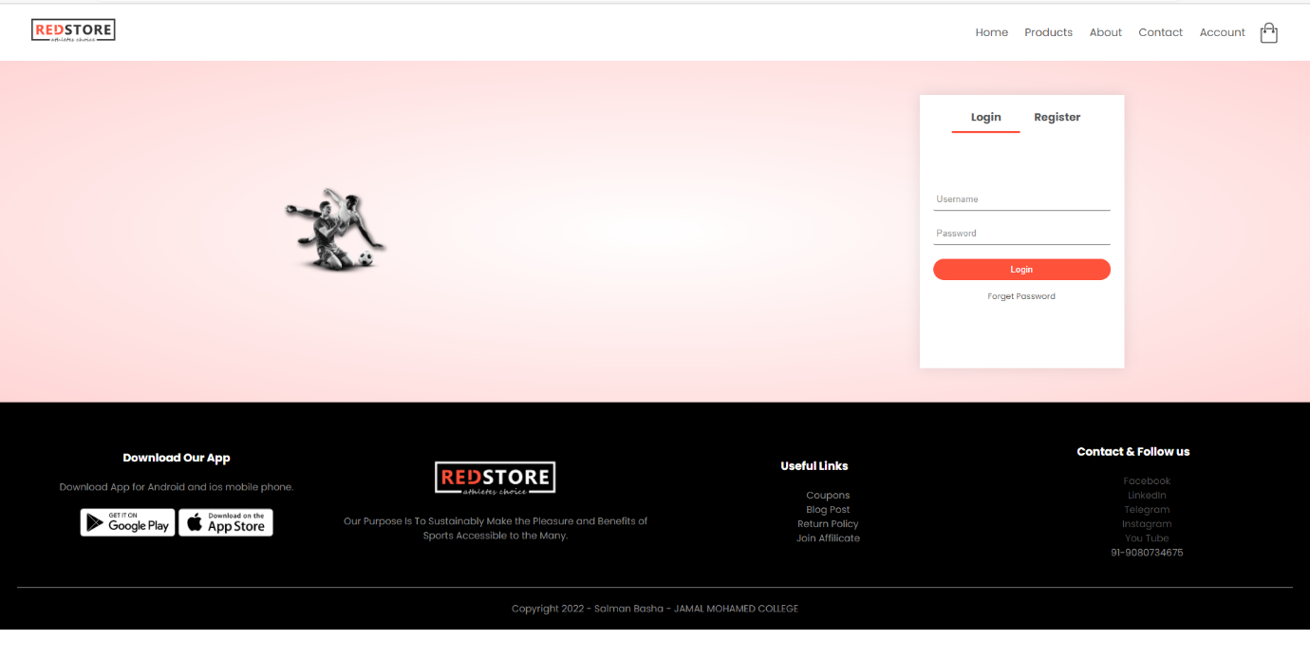

**HOME:**

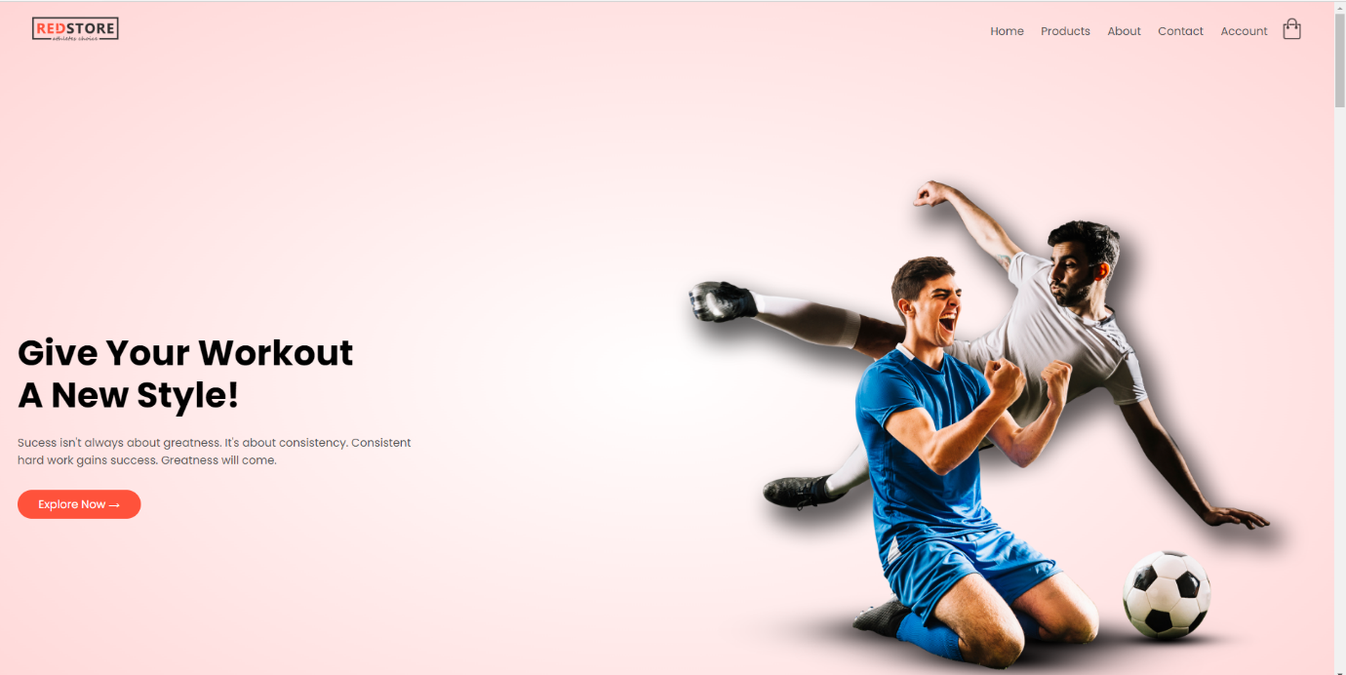

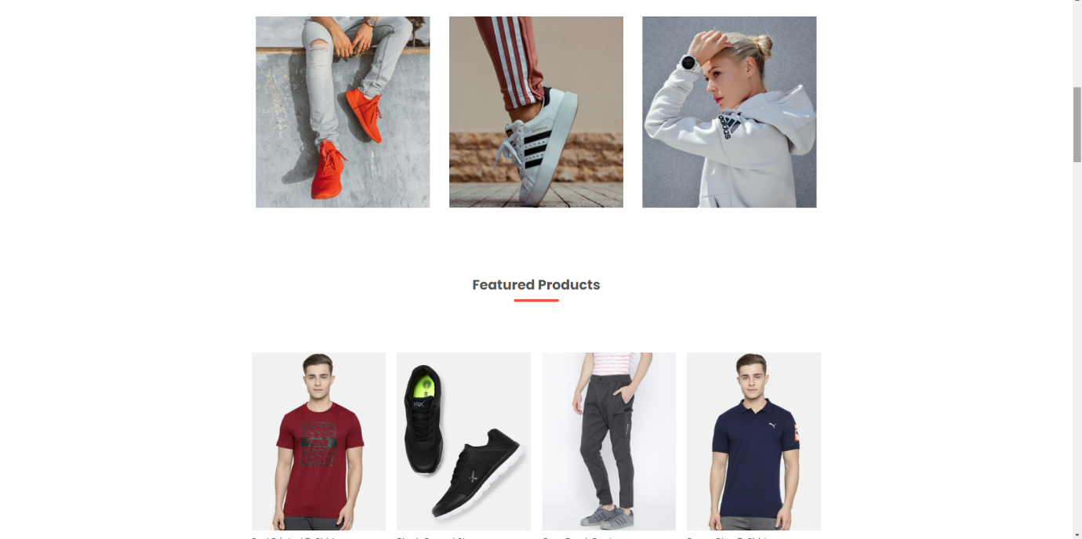

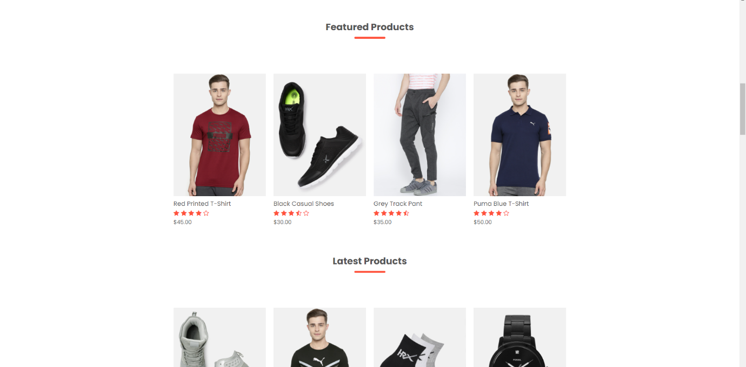

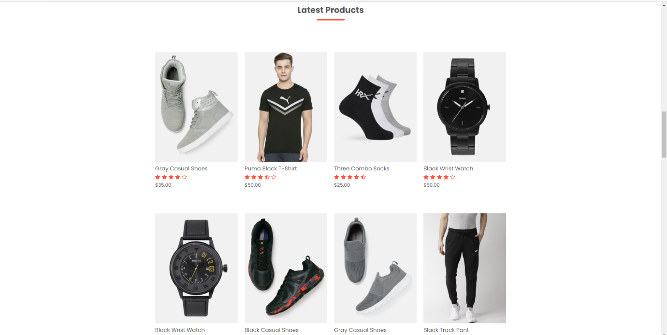

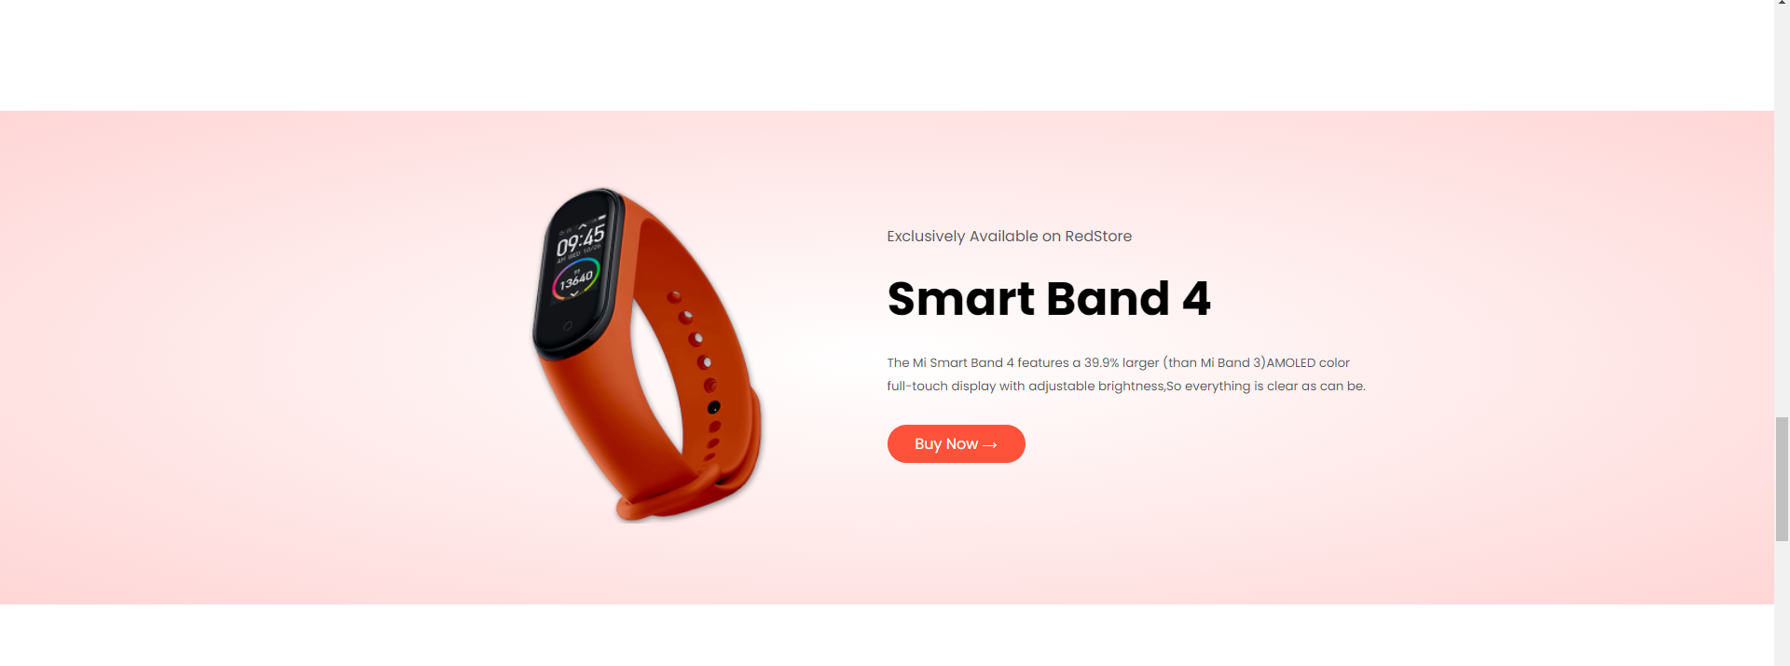

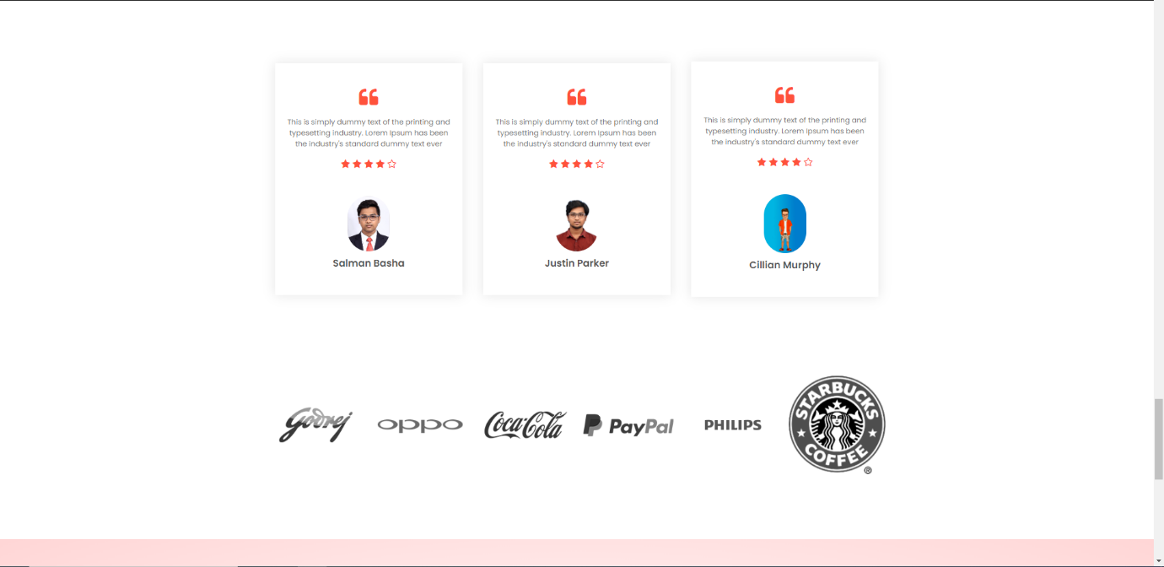

**ALL PRODUCT:**

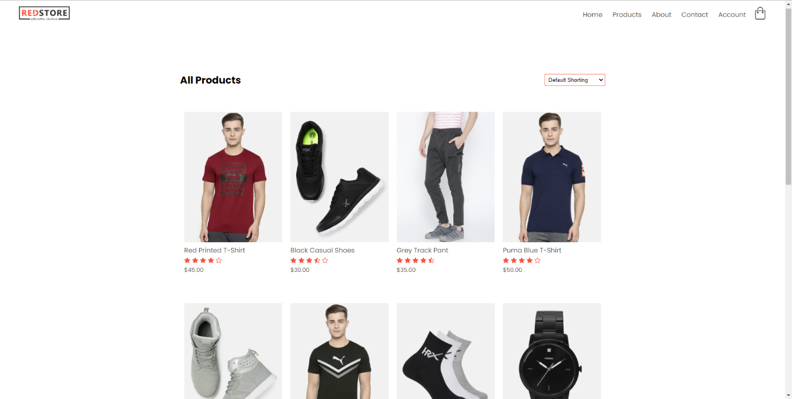

**PRODUCT DETAILS:**

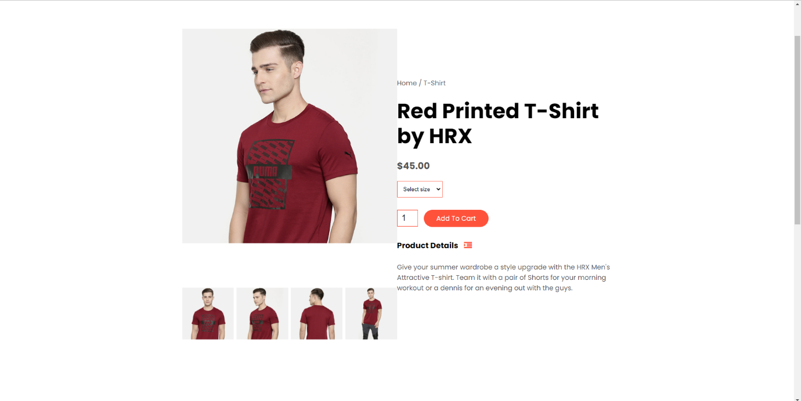

**CART PAGE:**

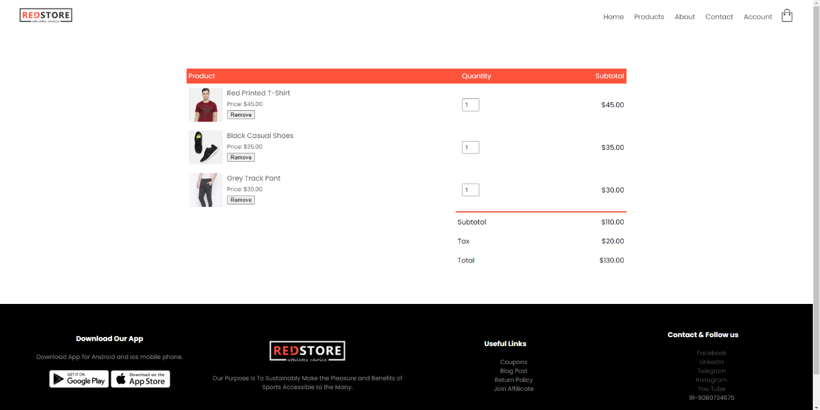

**ABOUT US & SERVICES:**

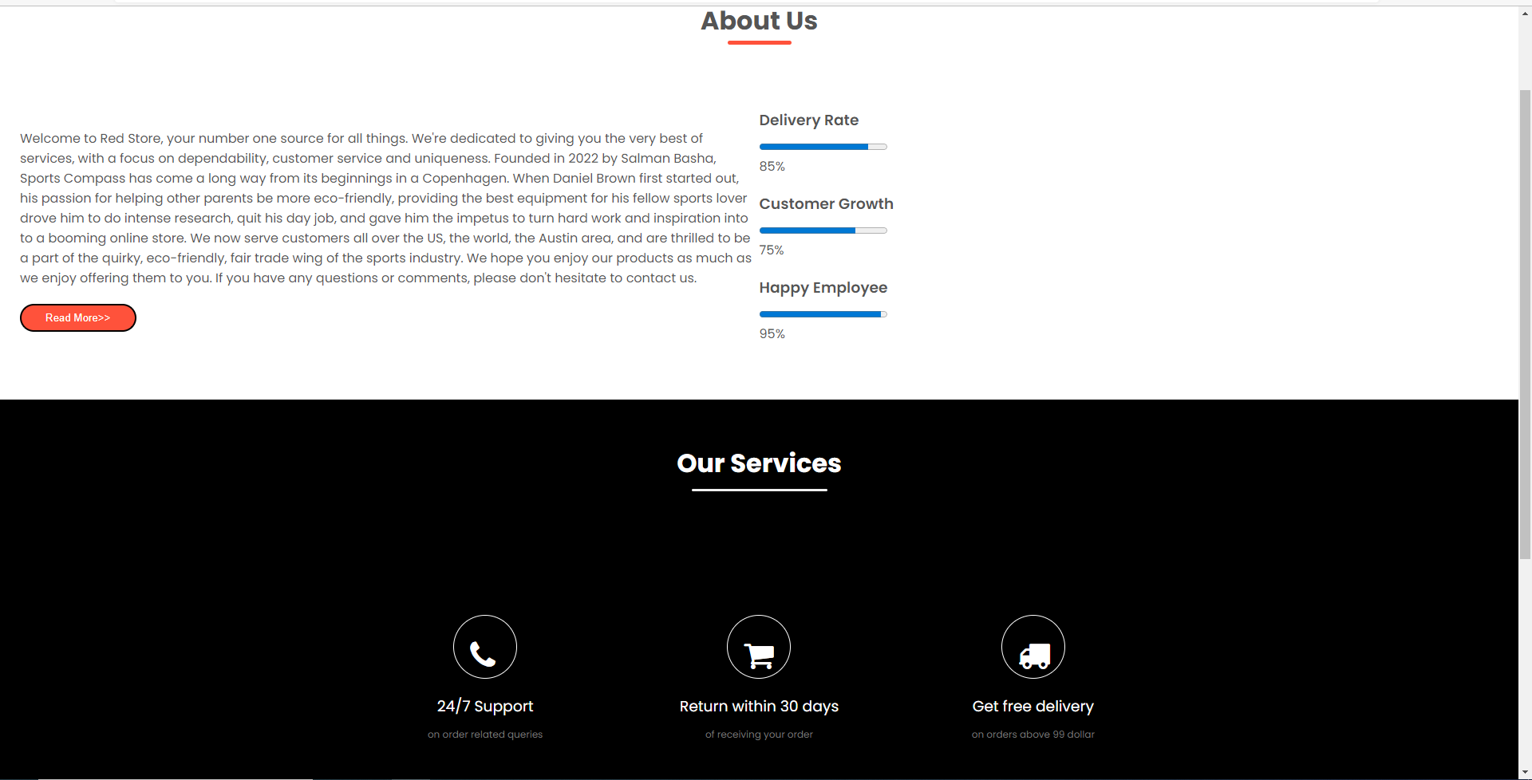

**CONTACT US:**

